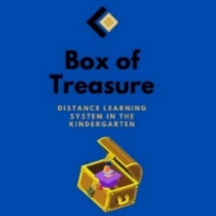
Box of Treasure
Lesson plan (draft version)
- Name of the Kindergarten, Country
- JOUDG Breshia, North Macedonia
- Lesson plan activity
- Ecological action-cleaning the yard and care for the environment
- Target group: children from 4-5 years
- Expected outcomes:
- The child knows how to take care of his environment
- The child actively participates in the care of the environment
- The child learns about the harmful consequences of the impact of garbage on wildlife
- Objectives:
- To encourage children to take care of the environment
- To develop a sense of awareness of cleanliness both inside the playroom and outside
- To develop cooperation and group cohesion between children
- To answer the questions asked
- Materials and means for realization
- Garbage bags, protective gloves
- Place of realization of the activities
- The yard of the kindergarten and classroom
- Activities:
- Morning greeting
- Circle of trust
- Spontaneous activities, and children are left to play without arranging the toys in their places before going to breakfast
- Breakfast
- We sit in a circle so that in the meantime the toys are not in place. They were asked the following questions: What do you see? What happens when we do not put the toys in place? Is our entertainment like this (untidy) or tidy? Why do toys need to be tidied up all the time? Then the children adjust the toys.
- Again the children are in a circle and we are taking two photos: the first photo is a park that is clean and tidy and the second photo of a park that is full of garbage. We are making a discussion and then we go out with the children in the yard of the kindergarten to clean it.
- We go back and share impressions from the ecological action of cleaning the yard
- Lunch
- Time for rest and sleep
- Snack
- Afternoon activities: Worksheets on which children will have to circle what is good and what is bad behavior
- Reflection:
- Photos and links

