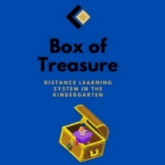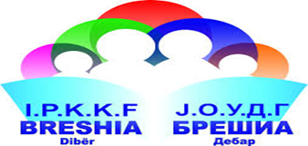
Box of Treasure
Lesson plan (draft version)
- Name of the Kindergarten, Country
- JOUDG Breshia, North Macedonia
- Lesson plan activity
- Care for the environment, making garbage bins
- Target group: children from 4-5 years
- Expected outcomes:
- The child knows how to take care of his environment
- The child actively participates in the care of the environment
- The child learns about the harmful consequences of the impact of plastic bags and bottles on wildlife
- Objectives:
- To encourage environmental awareness among children to preserve the environment
- To learn about the harmful effects on the environment and human health the use of plastic bags and bottles
- To encourage logical thinking about cause-and-effect relationships in children
- To answer questions based on what they see at the moment
- Materials and means for realization
- Educational video, plastic buckets, decorative material, scissors
- Place of realization of the activities
- Classroom
- Activities:
- Morning greeting
- Circle of trust
- Spontaneous activities
- Breakfast
- We are talking about what happened the day before - about cleaning the yard
- Educational video: Planet of plastic and pollution
- Making decorative garbage cans
- The bins are placed in the yard of the kindergarten
- Lunch
- Time for rest and sleep
- Snack
- Afternoon activities: Worksheet "Waste selection"
- Reflection:
- Photos and links: https://www.youtube.com/watch?v=0NtoL5mfizc&t=97s

