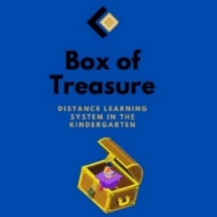
Box of Treasure
Lesson plan (draft version)
- Name of the Kindergarten, Country
- JOUDG Breshia, Noth Macedonia
- Lesson plan activity
- Planting the flowers
- Target group: children from 4-5 years
- Expected outcomes:
- The child knows how to name the parts of the plant
- The child knows how to take care of the plants
- - The child can draw on a smart board
- Objectives:
- To get acquainted with the parts of a plant (root, stem, leaf and flower)
- To get acquainted with the method of planting flowers
- To get acquainted with the function of each part of one plant
- To answer the questions asked
- To encourage care for plants
- Materials and means for realization
Pots, seedlings, planting accessories, electronic board
- Place of realization of the activities
- - The yard of the kindergarten and playroom
- Activities:
- Morning greeting
- Circle of trust
- Spontaneous activities. And if a child expresses a desire to draw they are given a direction to draw flowers
- Breakfast
- Poster with the seasons: The characteristics of spring are discussed with the children. The conversation focuses on plants in the spring by showing children photos of different flowers
- We go out and look for flowers in the yard, we compare them with the ones we saw in the photos
- Planting flowers: The children are previously explained that flowers can be planted in pots. Than together with the children the flowers are planted and the parts and the function of the parts of one plant are discussed.
- Children draw flowers on an electronic board
- Lunch
- Time for rest and sleep
- Snack
- Afternoon activities: Moving game for flowers, worksheets where children stick a collage. Discussion and repeating the procedure for planting flowers
- Reflection:
- Photos and links

