Nose Bleeding
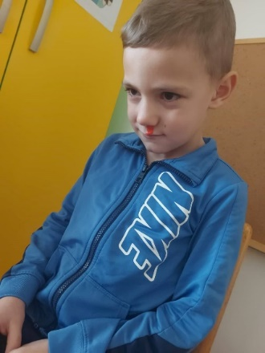

1.What has happen?
He has a nosebleed
2. How has happened?
While he was playing with his friend, he accidentally punches his nosе.
3. What could have been done to prevent this accident?
Talk to the children while they are playing, to be careful not to get into this situation. Because when children are playing, they get so involved in the game that they forget that something bad could happen
4. What do we need to do now after the accident has happened?
(1) Yell for help (find an adult), (2) Then press the boy’s nostrils closed, until helps arrived.
